DATA DICTIONARY

|  |  |  |  |  |  |
| --- | --- | --- | --- | --- | --- |
| **Field name** | **Datatype** | **Size** | **Constraints** | **Description** | **Table Name** |
| f_id | int | 10 | Primary key | Represent Farmer Id | Farmer,Orders |
| f_username | varchar | 10 | Not null | Represent Farmer Username | Farmer |
| f_password | varchar | 12 | Not null | Represent Farmer login password | Farmer |
| f_Name | varchar | 10 | Not null | Represent Farmer name | Farmer |
| f_email | varchar | 20 | Not null | Represent Farmer email | Farmer |
| f_MobileNo | int | 10 | Not null | Represent Farmer MobileNo | Farmer |
| f_Address | varchar | 20 | Not null | Represent Farmer Address | Farmer |
| C_id | int | 10 | Primary key | Represent Customer Id | Customer,Orders,Payments |
| C_username | varchar | 10 | Not null | Represent Customer Username | Customer |
| C_password | varchar | 12 | Not null | Represent Customer password | Customer |
| C_Name | varchar | 10 | Not null | Represent Customer name | Customer |
| C_email | varchar | 20 | Not null | Represent Customer email | Customer |
| C_MobileNo | int | 10 | Not null | Represent Customer MobileNo | Customer |
| C_Address | varchar | 20 | Not null | Represent Customer Address | Customer |
| Order_id | int | 10 | Primary Key | Represent Order Id | Orders,Payments |
| Order_quantity | int | 5 | Not null | Represent Order Quantity | Orders |
| Total_bill | int | 10 | Not null | Represent Total Bill | Orders |
| Order_Date_time | date | -- | Not null | Represent Order Date&Time | Orders |
| Delivery_address | varchar | 20 | Not null | Represent Delivery Address | Orders |
| Grain_id | int | 10 | Primary key | Represent Grain id | Grains,Orders |
| Grain_Name | varchar | 20 | Not null | Represent Grain Name | Grains |
| Grain_Variety | varchar | 20 | Not null | Represent Grain Variety | Grains |
| Grain_price | int | 10 | Not null | Represent Grain price | Grains |
| Total_Stock | int | 10 | Not null | Represent Total Stock | Grains |
| Payment_id | int | 10 | Primary key | Represent Payment Id | Payments |

USE CASE DIAGRAM FOR ORDER AND PAYMENT

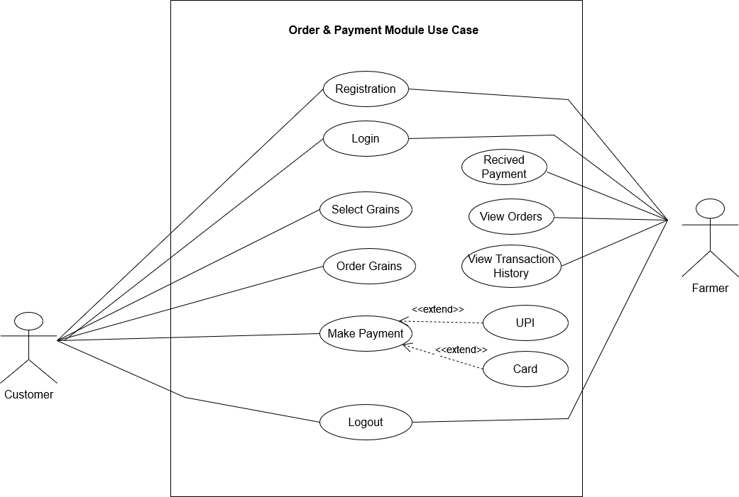

ACTIVITY DIAGRAM FOR ORDER AND PAYMENT

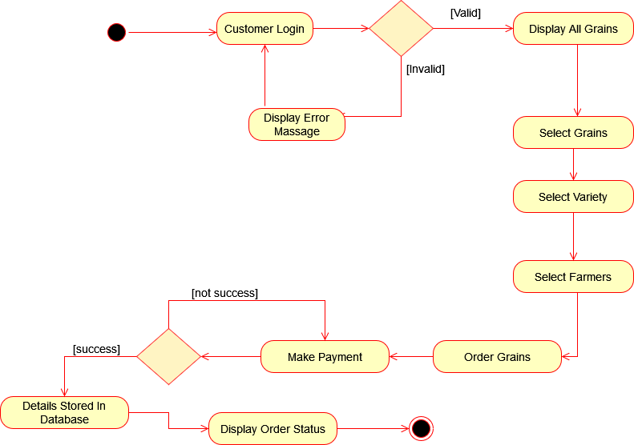

COMPONENT DIAGRAM OF SYSTEM

